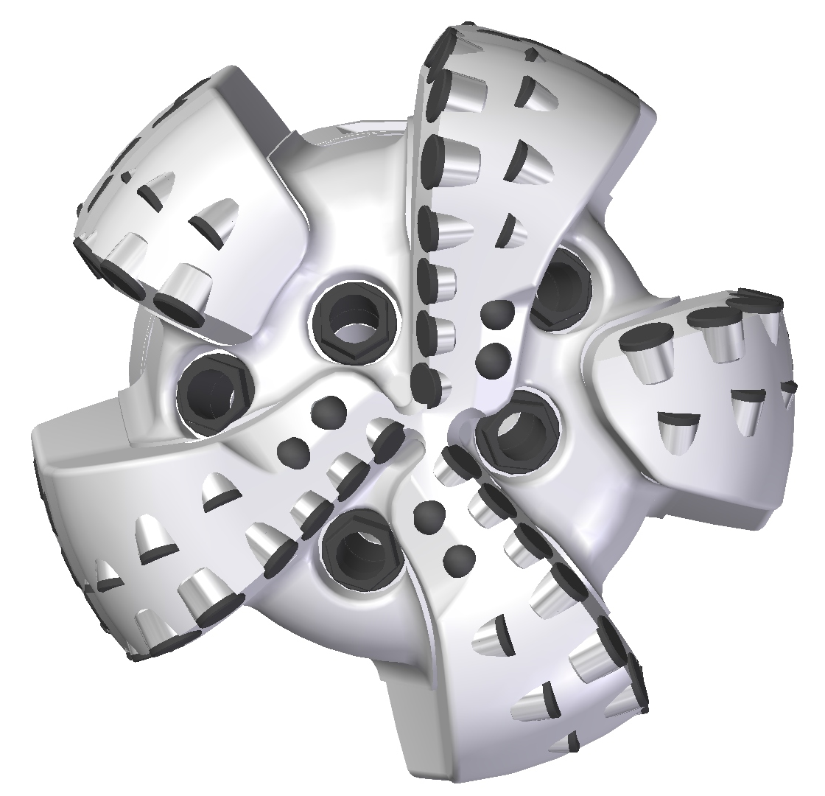 |  | 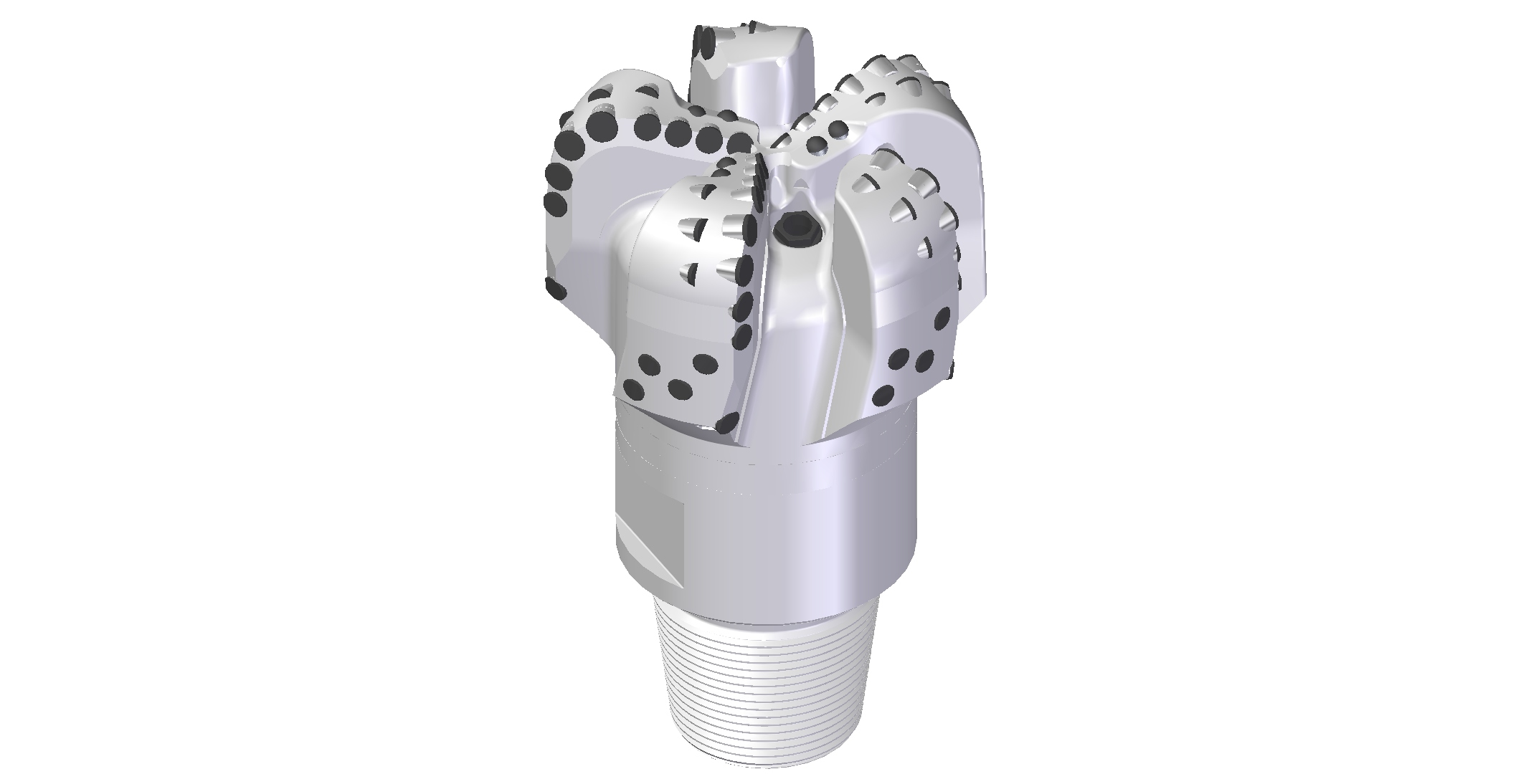

Drill Bit Specifications:
Cutter Size (Primary, Sec) |  | 5/8”, 1/2”
Cutter Count (Total, Gage, Back Ream) |  | 55, 5, 5
Blade Count |  | 5
Gage Length (Inches) |  | 2.00
Nozzle Count (Primary, Sec.) |  | 5
Nozzle Size (Primary, Sec.) |  | 60
JSA (Sq. Inches) |  | 14.08
Max. TFA (Sq. Inches) |  | 1.85
Operating Parameters:
Hydraulic Flow Rate (GPM) |  |  | 255 - 670
Make-Up Torque (FT-LBS) |  |  | 16,488
Max. Weight on Bit (1,000 Lbs.) |  |  | 32
Nominal Dimensions:
Overall Length (Inches) | 14.10
Make Up Length (Inches) | 10.04
Bit Breaker | SKB-21010
Connection | Ø4-1/2" API Reg.
Approx. Weight (Lbs.) | 95

Standard Features:

- Short bit length improves steerability
- Large open face volume assists cuttings removal
- Five nozzles optimize blade cleaning and cuttings removal
- Premium grade cutters maximize ROP and Life
- PDC inserts for increased gage protection

516-YR (K)(BR) Nomenclature Explained:

- 5 = Number of blades
- 16 = Primary Cutter Size (16mm)
- K = Bullets
- YR = Double Row Cutters
- 5 = Number of Nozzles
- BR = Back Reaming Cutters
Interchangeable nozzles.

